**MATHEMATICAL MODELLING OF BIOLOGICAL SYSTEMS**

**MANYA B**

**AM.BT.P2BIF20019**

1. Install 2 operating systems

Installing Linus in to System

* Downloading Linux distribution iso file from linux

Link to downlod linux distribution : [Download Ubuntu Desktop | Download | Ubuntu](https://ubuntu.com/download/desktop)

* Creating Bootable USB drive using Rufus

Link to download Rufus : [Rufus - Create bootable USB drives the easy way](http://rufus.ie/en/)

* Select iso file that is downloaded in the system in order to make ubuntu bootable device

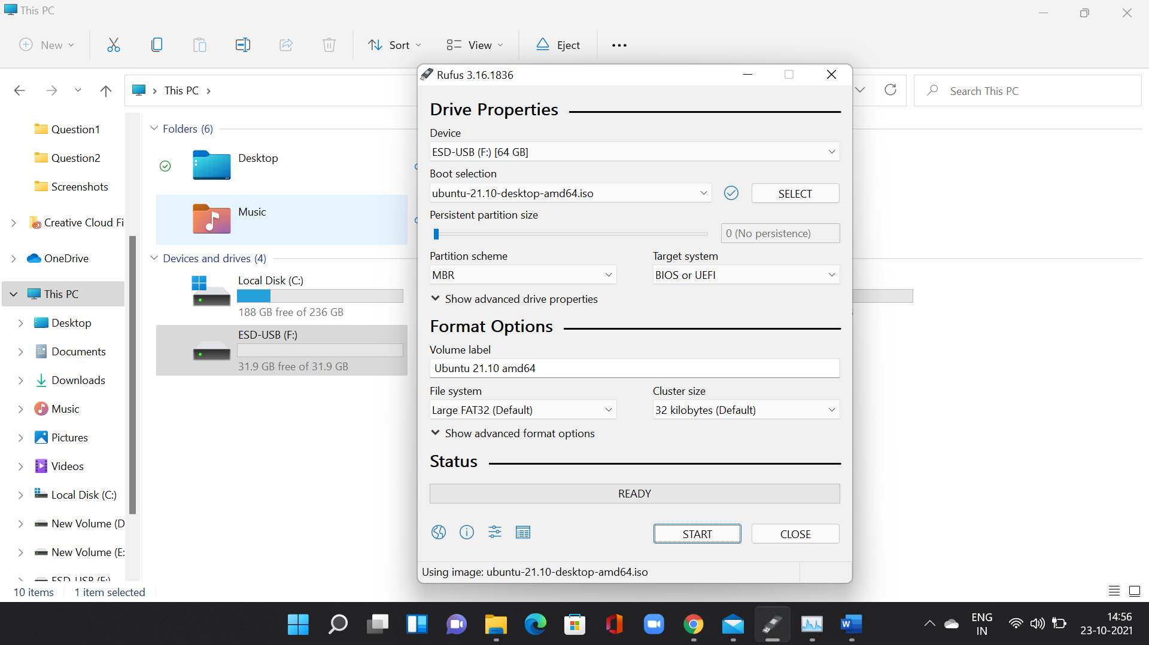

* Set other parameters
  + - Partition scheme-MBR
    - Target System-BIOS or UEFI

* Click start button to create Bootable USB drive after giving all parameters

* After creating bootable media
* Restart the PC and tap the boot key (Esc, F9,F12)

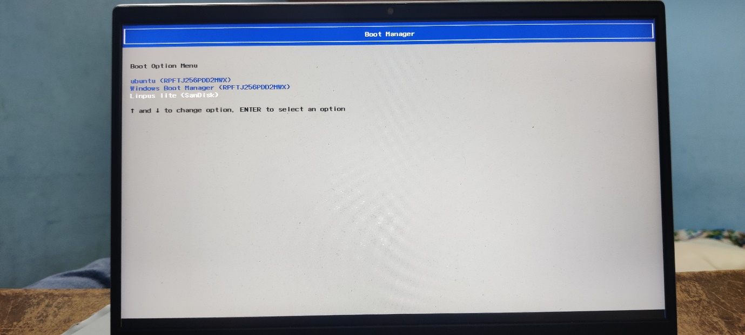

* + Select the device that we created media



* + - System will start the Linux installation process
      * Select install ubuntu it will help to install ubuntu inside your hard drive

* + - Creating disk partition to install the OS

After successful installation of the Linux, Restart the system

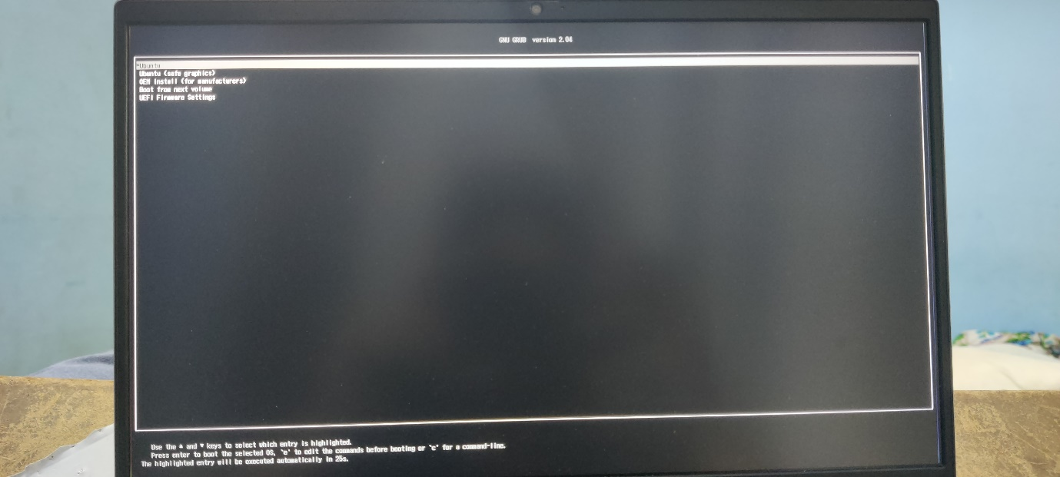

System will ask as which Operating system to be booted here I have Windows 11 and ubuntu installed in this machine now

Ubuntu already have python IDLE

**Installing third Operating system Zorin into the machine**

* Creating Bootable media using Rufus

* Open the system boot screen to boot the media device created

* Select zorin os that need to be installed

* Start the installation by selecting install Zorin operating system to disk drive.

* Installation options

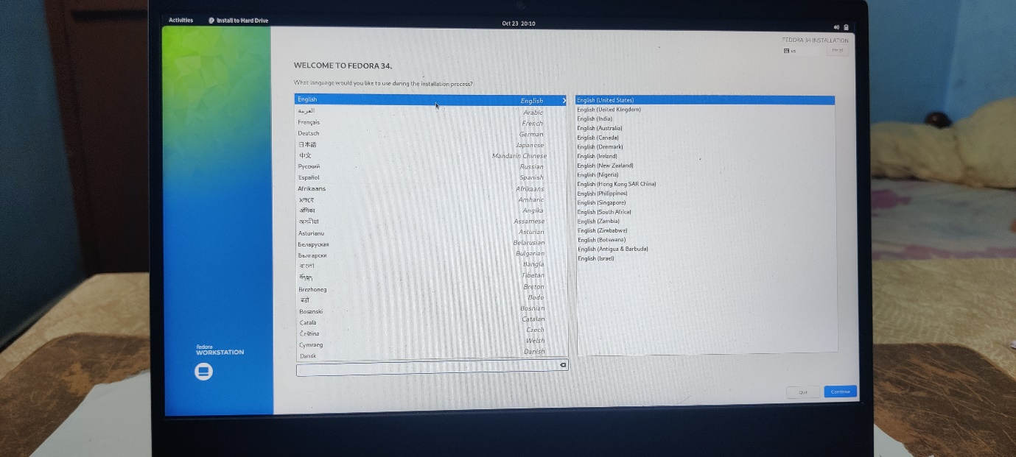

* Installation Disc selection

* Installation progress

* Installed Zorin OS
* Machine is installed with Three operating system ubuntu, Zorin and Windows

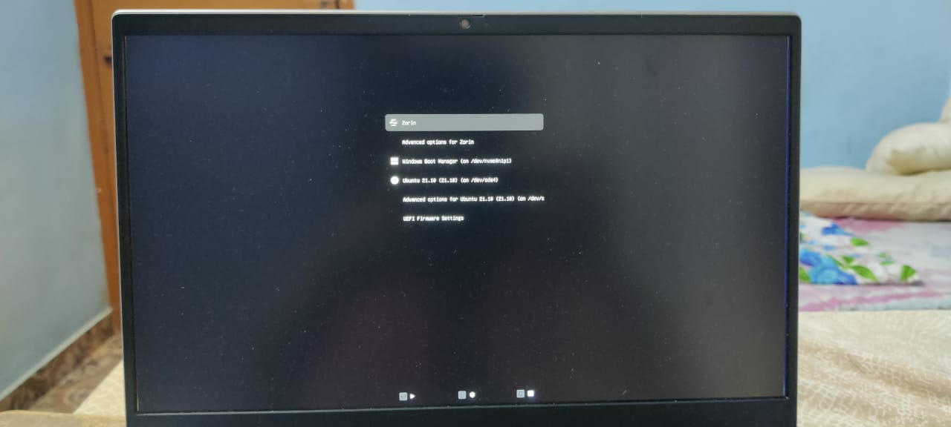

* Python IDLE Installation

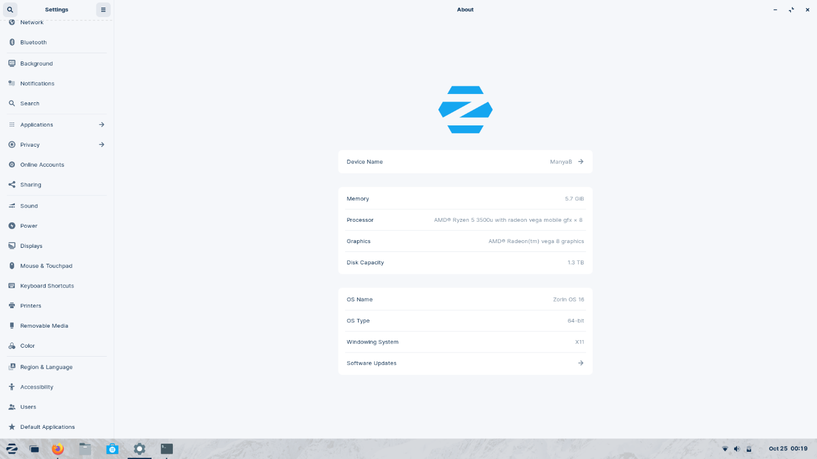

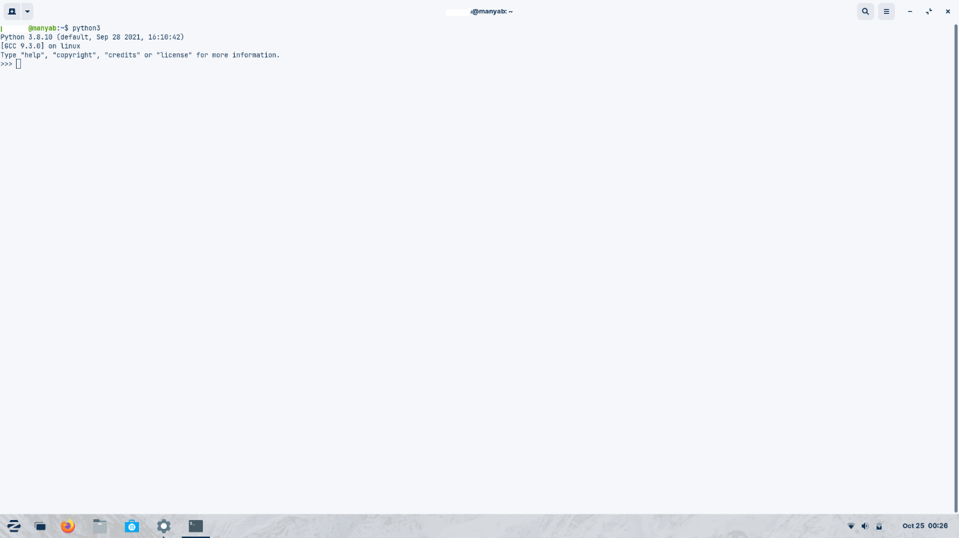

**2. What are shell and kernel of system. Also comment on their functions?**

Kernel – core of operating system’s core, controlling all the system’s function. Also called heart of operating system that manages the operations of computer and hardware.

Shell – special user program that allows user to communicate with the kernel . it executes programs based on the input provided by the user

Shell also known for interpreter , as it takes data from the user and converts it from human understandable form to machine understandable form whereas Kernel processes the request of the shell.

Kernel performs several operations like it checks whether the process is running or waiting, It allocates and de-allocates process, when a kernel determines that the logical memory doesn’t fit to store the programs then uses the concept of physical memory and store into temporary manner., kernel stores files into computer systems such that no one can read or write the files without permissions.

Shell is a command-line interpreter whereas kernel is a low level program interfacing with hardware on top of which applications are running.

Different types of shell – Bourne shell, C shell, Korn shell etc.

Different types of Kernel – monolithic kernel, micro kernel , hybrid kernel etc.

APPLICATION

SHELL

SHELL

USER

APPLICATION

KERNEL



3. **What is an operating system?**

* An interface between user and a hardware
* Any systems need at least one operating system inorder to run its applications .
* The operating system act as an intermediatory between the programs and computer hardwares inorder to perform hardware functions such as input and output and memory allocation.
* Some functions of operating system involves: memory management, processor management, file management, device management, security, control over system , error detecting, job accounting , coordination between other softwares and users.